Chapter 9
System Software and Operating System

Lesson 9.1: System Software
Lesson 9.2: Introduction to Operating Systems
Lesson 9.3: Processing and Services
Lesson 9.4: Popular Operating Systems

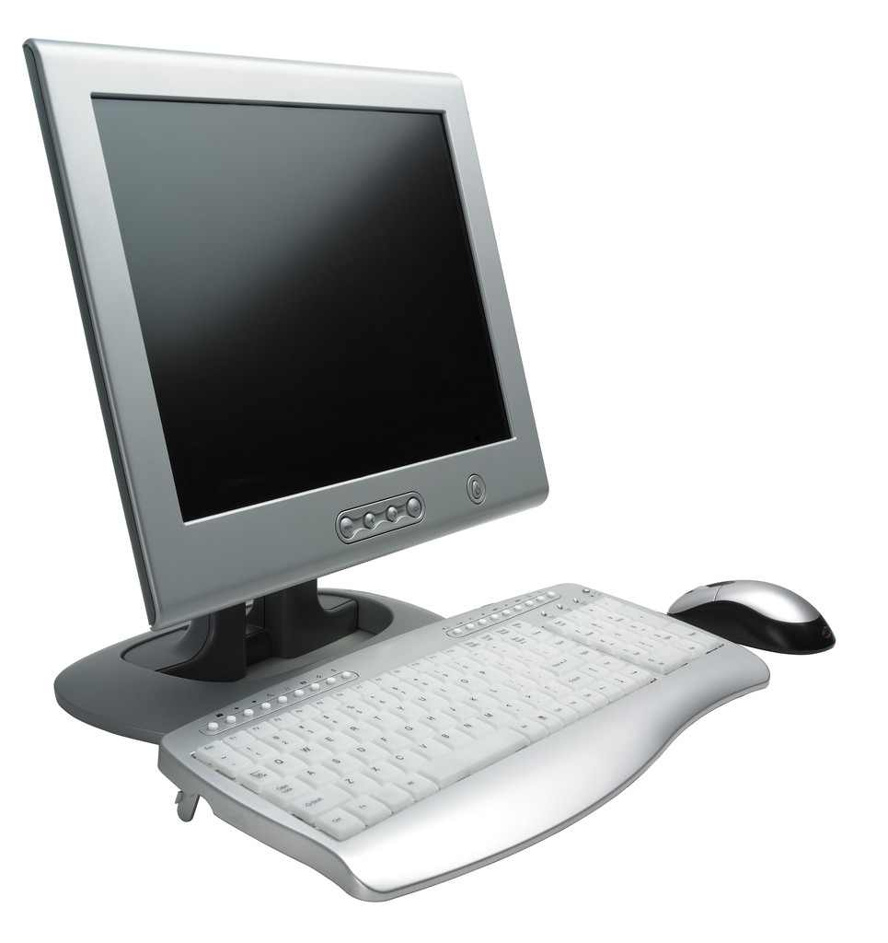

Lesson 9.1
System Software

9.1.0 Objectives
On completion of this lesson you will know:
- The concept of system software
- Role of operating system and BIOS
- Function of language translators
- Testing, debugging and diagnostic program.

9.1.1 System Software
System software refers to programs that assist the users to generate, debug, test, modify application programs, and then to execute them. These programs are generally written by computer manufacturers or software developers. The system programs can be used by different users and different application programs. The programs of system software can be broadly grouped into:
- Operating systems
- Language translators, and
- Utility programs.
The most important component of system software is the operating system. It is a collection of program modules. They manage all the hardware, and provide some other user facilities. Other system programs include language translators (i.e. `), text editors and utility programs.
An operating system is a software system. It acts as an interface between a user of a computer and the computer hardware. The operating system provides an environment in which a user may execute programs. The main goals of an operating system are to:
- Make the computer system convenient for users
- Make efficient use of the computer hardware.
An operating system controls and coordinates the use of the hardware for different application programs. The basic resources of a computer system are provided by its hardware, software and data. The operating system provides the means for the proper use of these resources in the operation of the computer system.
A computer system can be viewed to have four components (Figure 9.1.1):
- Hardware (CPU, memory, I/O devices etc.)
- Operating system
- Application programs (compilers, database systems, video games, business programs etc.)
- Users (people, machines or other computers).

Compiler Assembler Text Editor Data Base System

Application Programs
Operating System
Computer Hardware
User 1
User 2
User 3
User n
Figure: 9.1.1: Overview of a computer system.

9.1.2 Compiler and Interpreter
High level languages are widely used. They have been developed to enable the users to program the machine in a language similar to the language of the users. For example BASIC, Pascal, C and Java use scientific notations and subroutines in programming formats that are similar to mathematical formulas and equations. On the other hand, COBOL contains business jargons widely used in business. Figure 9.1.2 shows language translator translate high level language into machine language.

Source Program
(Assembly Program, or high level language program)
Language Translator
(Assembler, Compiler, Interpreter)
Object Program
(Machine Language)
Figure 9.1.2: Language translators.
Compiler: A Compiler is a program that translates programs written in high level language into machine language. A program written by a programmer in a high level language is called a source program. The source program when converted into machine language by a compiler is referred to as an object program. Unlike the assembler, the compiler generates several machine language instructions for each source statement. A compiler can be made to interface with several different computers. It is not written for any specific computer. A user can write programs that can be adapted to several computing systems. Thus the user can formulate problems efficiently without precise knowledge of computer architecture. Compilers are complex programs compared to assemblers and they require more storage space than assemblers. An assembler or a compiler produces the object program, which is loaded into the computer memory before execution.
Interpreter: An Interpreter is a translator program that differs from the assembler or the compiler on several significant points. The interpreter does not prepare an object program. It translates and immediately executes each instruction of the source program. Thus an interpretive language is also an interactive language; it enables the user to load one instruction into the computer at a time and it is translated and then executed. This process allows the programmer to check the results immediately. The interpreter is also a debugging tool and is useful during the program development stage. In the interpretive mode the execution time of the program is extended, but program development effort and program development time are decreased. Table 9.1.1 shows comparison between compiler and interpreter

Table 9.1.1: Comparison of Compiler and Interpreter
Compiler | Interpreter
Compiler prepares an object program from source program | Interpreter translates and immediately executes each instruction of the source program
Debugging is complex and time consuming | It is a debugging tool and is useful during program development stage
Lower execution time | Higher execution time
Requires more program development effort and time | Requires less program development effort and time

9.1.3 Text Editor
While developing a program, it is often necessary to edit it. Editing involves making corrections or modifications to instructions, deletions and additions of instructions, re-sequencing instructions etc. A special system program, called editor, simplifies the editing tasks greatly. An editor enables the user to retain the program in the memory and modify it as required. A portion of the memory, called buffer, is reserved for editing. Lines of instruction are entered from an external I/O device and stored in the buffer for editing by the editor. The edited text can be printed by a printer or recorded on suitable I/O devices.

9.1.4 Testing, Debugging and Diagnostic Programs
Programs created by us are prone to error. It is not realistic to expect a newly created program to run for the first time. Before a program can be put into productive use it must be debugged. A bug is a defect or imperfection in a program. In the context of programming it is an error in a program that is responsible for undesirable results. Testing of a program involves validation of program design. Thus testing involves data that are intentionally used to reflect the worst-case situations.
In order to assist the programmer in locating and rectifying errors or bugs in programs several tools are available. These tools could be hardware aids such as logic analyzers or software aids such as debug programs. A debug program is loaded into the memory with the object program that is to be debugged. If errors occur during run, the debug program is activated to identify, locate, and correct the error. A debug program generally includes several features that aid the programmer in debugging tasks. Some of the common features are described below.
Display Register Contents: This feature allows the programmer to check contents of certain registers of the CPU during the execution of a program. The contents of the registers can be printed or displayed on appropriate devices. It is also possible to modify the contents of some registers if necessary.
Display/Replace Memory Contents: The programmer can access the contents of a memory location and display it. The contents can then be modified if necessary.
Memory Dump: This feature makes it possible to print the contents of a group of memory locations. Thus a programmer can view the contents of desired memory locations and determine accuracy of data.
Output Memory Contents: The contents of a memory are transferred and stored in some other mass storage devices such as disks or magnetic tapes.
Breakpoints: Breakpoints are interrupts in the object program. They are used to examine the current status of certain critical CPU registers, memory locations, or I/O ports. When the execution of the object program reaches a breakpoint, its execution is temporarily halted. The debug program then allows the programmer to examine and alter the contents of the selected register, memory locations, or I/O ports to correct errors.
Disassembly: This is the reverse of the assembly process. The operation consists of reading out the contents of the program memory into assembly language.

9.1.6 Key Points
- System software refers to a program that assists the users to generate, debug, test, modify application programs, and then to execute them.
- An operating system acts as an interface between a user of a computer and the computer hardware.
- A Compiler is a program that translates programs written in high level language into machine language.
- A program written by a programmer in a high level language is called a source program.

9.1.7 Exercise
Multiple Choice Questions
- An operating system is a program which acts as an interface between __________.
  - user and application program
  - user and hardware
  - application program and hardware
  - none of these
- ________________ prepares an object program from source program.
  - Assembler
  - Compiler
  - Interpreter
  - None of these
- Which one translates and immediately executes an instruction?
  - Assembler
  - Compiler
  - Interpreter
  - None of these
- A Compiler is a program that translates ________________ .
  - An object program to a source program.
  - A handwritten program to a source program.
  - A source program to an object program.
  - none of these

Review Questions
- What is meant by firmware?
- What is the main function of a language translator?
- Distinguish between assembler and compiler.
- Give the main characteristics of an interpretive language.
- List the main features of a debug program.
- List the main functions of a text editor.

Analytical questions
- What is a language translator? Discuss characteristics of different types of language translators.
- Discuss the disadvantages of machine language programming.
- Distinguish between compiler based languages and interpreter based languages
- What is a debug program? Discuss the major features of a debug program.

Lesson 9.2
Introduction to Operating Systems

9.2.0 Objectives
On completion of this lesson you will know:
- Tasks of operating systems
- Types of operating systems
- File management
- Utility programs.

9.2.1 The Tasks of Operating Systems
The most important task of an operating system is to process commands and to provide coordination between different processing tasks.
Processing Commands
An operating system interprets instructions entered through an input device such as a keyboard. When a user uses an application program, the program's commands are interpreted by the operating system. For example, one might open a document by clicking a button on the program's toolbar. At another time the user might do so by dragging the file onto the application's icon and dropping it. The operating system interprets these commands and copies the document on the disk of the computer.
Multitasking
Multitasking is a method where multiple tasks, also known as processes, share common processing resources such as CPUs. In the case of a computer with a single CPU, only one task is said to be running at a time, i.e., the CPU is actively executing instructions for a task. Modern operating systems allow multitasking, i.e., an operating system can perform multiple tasks at the same time with different programs. For example, one could download a large file from the Internet with one program, while editing a document with another. Older operating systems could run only one program at a time. Since most systems have only one microprocessor, they allow multiple programs to run by quickly switching back and forth between them. Although only one program is actually active at a time, the processor witches so fast that they all appear to be active. This process is called time-slicing or task-switching because it slices up the CPU's time as it switches between the running applications. Today's system use a form of multitasking called preemptive multitasking. In this type of multitasking access to the microprocessor is controlled so that one application can not seize it and hold it for a long period. One application can "preempt" mother application to get a fair share of the processor's time.
Multithreading
Most applications process data and commands sequentially, i.e. when one task is finished they begin another. The application, therefore, follows a single thread from the beginning of a session to the end and individual operations are strung like beads on a necklace. A multithreaded operating system, on the other hand, lets application programs start and run two or more threads simultaneously. It is similar to multitasking within a single program. For example, one thread in a word processing program can be reading the pressed keys while a second thread displays data on the screen and a third thread prints the document.
Multi-user Support
Some operating systems are designed so that many users can be connected to the system at the same time. Multi-user operating systems are also multitasking because the multiple users run their programs at the same time.
Multiprocessor Support
Some applications need huge processing power. For example, forecasting, modeling, simulation, and computer aided design needs enormous computing power. Multiprocessor systems support multiple processors for different application- in some cases thousands or even more.
Miscellaneous Tasks
In addition to the processing tasks discussed above, an operating system also performs the following tasks
- The operating system continually monitors the system and outputs an error message, if it detects something wrong.
- The operating system manages the use of memory and runs each program in its
own protected space so that a problem with one program will not affect others.
- The operating system allocates peripheral devices for different tasks.
- To conserve power, power management cuts power at those times when it is not needed.
- Manages files stored on disks.

9.2.3 Operating System Characteristics
There are a variety of criteria, some of which can be used to compare operating systems. These are as follows:
- Character-based or graphical user interface based
- Single tasking or multitasking
- Single threading or multithreading
- Weak or strong security
- 8, 16, 32, 64 and 128 bits processed at a time
- Portable or not (a portable operating system is not dependent on a specific microprocessor.)
- Proprietary or open (proprietary operating systems work only with one type of computer, open operating systems run on a variety of machines).

9.2.3 Types of Operating Systems
Desktop Operating Systems
Operating Systems that run on desktop computers are the least powerful and least secure operating systems. They are also the most common. Three common types are:
- Windows,
- Unix and Unix-like operating systems
- Rapidly fading DOS.
Operating Systems for Servers
Computers in networks are connected to one another not directly but through powerful computers, called servers, that provide security to the networks and route traffic from one network to another. These complicated tasks require special operating systems. These powerful operating systems are also used for tasks (such as engineering design, order processing, and payroll) critical to a organization's continued existence, called mission critical applications. Such tasks were previously run only on larger mainframe computers. These powerful 32-bit, 64-bit or 128-bit operating systems are secure, multitasking, multithreading, open, and possesses graphical user interfaces developed for them.
- Windows Server 2008 (sometimes abbreviated as "Win2K8" or "W2K8") is one of Microsoft server line of operating systems released on February 2008. It is the successor to Windows Server 2003, released nearly five years earlier. A second release, named Windows Server 2008 R2, was released to manufacturing on July 2009. Like Windows Vista and Windows 7, Windows Server 2008 is based on Windows NT 6.x (NT stands for New Technology).
- UNIX is a multitasking, multi-user operating system originally developed in 1969 by a group of AT&T employees at Bell Labs of USA. The Unix operating system was first developed in assembly language, but by 1973 had been almost entirely recoded in C, greatly facilitating its further development and porting to other hardware.
- Linux (or GNU/Linux) is a Unix-like operating system that can be used on a wide range of devices from supercomputers to wristwatches. The Linux kernel is released under an open source license, and anyone can read and modify its code. It has been modified to run on a large variety of electronic devices. Although estimates suggest that Linux is used on small percentage of all personal computers, it has been widely adopted for use in servers and embedded systems (such as cell phones). Linux has superseded Unix in most places, and is used in most powerful supercomputers in the world. The Linux kernel is used in some popular distributions, such as Red Hat, Debian, Ubuntu, Linux Mint, Google's Android etc.

Operating Systems for Mainframe
In the early days of computer, mainframe and minicomputers dominated the computing world, and each computer company developed its own operating system. For example, some IBM mainframe computers use an operating system called open VMS (Virtual Memory System) and Digital Equipment Corporation minicomputers use one called VMS. These companies developed not just their own operating systems but also the applications that ran on top. These are called proprietary systems because they are all owned by a single proprietor. Because there were so many competing operating systems, it was hard to make computers talk to one another. Although costly, these operating systems are both powerful and secure and capable of handling a variety of tasks.

Handheld operating systems
A handheld operating system, also known as a mobile operating system, or a mobile platform, is the operating system that controls a mobile device or information appliance—similar in principle to an operating system such as Windows, Mac OS, or Linux that control desktop computers or laptops. Operating systems that can be found on smartphones include Nokia's Symbian, Google's Android, Apple's iOS, RIM's BlackBerry OS, Microsoft's Windows Phone, Linux, HP's webOS, etc. These operating systems are operated using a small keyboard and/or a touch- sensitive screen.

Embedded operating systems
An embedded operating system is an operating system for embedded computer systems. These operating systems are designed to be compact, efficient, and reliable, neglect many functions that non-embedded computer operating systems provide, and which may not be used by the specialized applications they run. They are frequently also real-time operating systems, and the term RTOS is often used as a synonym for an embedded operating system. Examples of embedded OS are Symbian OS, Windows CE, Embedded Linux, Android, ipodlinux, Cisco IOS etc

9.2.4 File Management
File
A computer file is a block of arbitrary information, or resource for storing information, which is available to a computer program and is usually based on some kind of durable storage. A file is durable in the sense that it remains available for future use. Computer files can be considered as the modern counterpart of paper documents which traditionally are kept as files in offices and libraries.
Filenames
When files are saved, they are assigned filenames so that users can identify them later. Filenames have two parts:
- A name, and
- An extension.
One may think of them as first and last names. The name is chosen to identify the file later. For DOS, a user has to use limited number of characters for the file name. However, a user can use long, descriptive filenames in newer operating systems.
The extension is separated from the name by a period. Its purpose is to identify the file format or the application that created it. For example, a .mdb extension means the file is a database and .doc often means a word processing document or file.
Folders
A folder contains related documents together. A well organized file cabinet uses hanging folders to group related documents. If a further breakdown is needed, manila folders are inserted into the hanging folders. It is then easy to locate and pull out the documents needed. The same is true of hard drives. To master computing, one needs to understand the concept of folders and their use for grouping together related files. A folder is also known as directory.
Drives
Most of the computer systems have more than one drive as named in Figure 9.2.1. Drives are assigned letters for identification. For example, a drive into which user can insert a floppy disk may be drive A or B. A computer looks to hard drive, called C, when user turns it on. Additional drives might be D and E. As the number and type of drives vary from system to system, thus the letter or name of each varies.

Floppy drive A & B (nearly obsolete)
Hard drive C, D
DVD-ROM drive E
Zip drive/Flash drive F
Figure 9.2.1: Drives and usual drive names
Trees
A tree is one of the ways to illustrate the organization of folders on a drive. In this view, all folders branch off from the drive. If a folder contains other folders, those folders are shown as a second branch from the first. Figure 9.2.2 shows tree, folder and file in Windows platform.
When using a tree, one can expand and collapse the entire tree or any branch. This allows a user to alternate between a summary of the drive's contents, and details of each file. On Windows, the plus sign indicates that a branch has been collapsed and it contains hidden folders. The minus sign indicates that the branch has been expanded.

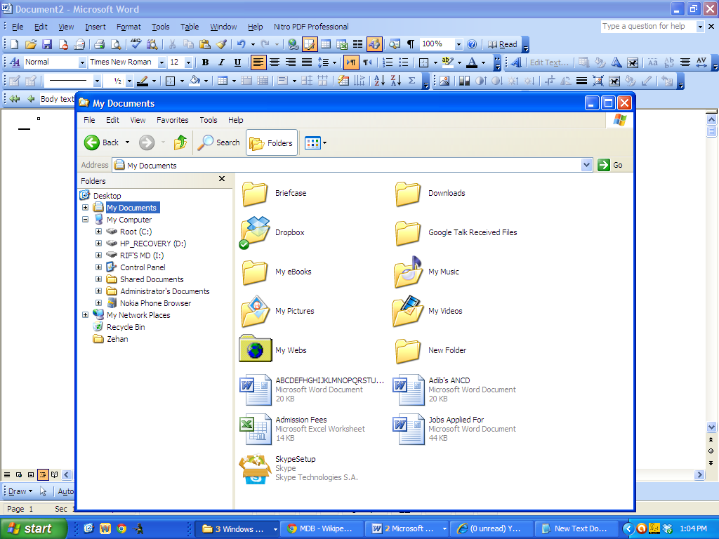
Tree
File
Folder
Figure 9.2.2: Tree, folder and file in Windows platform
Paths
A user has to follow a "path" to get files stored in folders on a disk. For example, if a file named Adib.doc is in a folder named ‘Documents’ on drive C, the path to that folder is C:\Document\Adib.doc. If Adib.doc is in a folder named ‘Application’, the path is C:\Application\Adib.doc. The drive specification in the path is C: and the folder's name is separated from it by a backslash.
Path to a file in a folder: The backslash is also used when a user has folders within folders. If the ‘Letters’ folder contained a folder named ‘Vendors’, the path to it would then be C:\Letters\Vendors\List.xls. Here List.xls is the stored file.
Path to a file in a subfolder: In most cases, a user does not need to type paths. Most new programs and operating systems let users to use a mouse to open folders to find a file.
File managers
Operating systems include a separate program that a user can use to explore drives, folders, and files. There are a variety of these but they all allow users to display the folders on a drive arranged like a tree. Clicking any of the folders displays a list of its contents. For example, Figure 9.2.2 displays the contents of the folder named “My document” which has been selected.
When browsers and search engines were first developed for the Web, people soon discovered they could locate and get to a document anywhere in the world more easily than they could locate and get to one on their own system. As a result, browser technology is now being put to use in file management. Microsoft's Active Internet Platform technology allows users to browse documents as well as the Web. In fact, a document on a local hard drive looks the same as a page anywhere on the Web.
Search engines on the Web keep track of millions of documents by searching them out and listing words they contain in an index. When a user searches a word, the search engine looks it up in the index and lists the name and address of every document in which it can be found. A user can go to the document just by clicking its name. The search engines make looking for documents so easy that personal versions are available for users own system.
Utilities
In addition to a file manager, operating systems also include utility programs that one can operate to manage disks and files. The list of such utility programs is almost endless. Some commonly used utilities are briefly discussed below:
Disk Formatting
Disk formatting utility makes the disk ready to store data. Formatting directory creates a directory of the locations of each file called a file allocation table (FAT). When a user saves a file, the operating system stores it in a group of sectors, called cluster, the smallest storage unit the computer can address. To do so, it looks in the file allocation table for empty clusters and then stores the file in one of those locations. The address of the cluster where the file begins and the one where it ends are then listed in the file allocation table. When a user opens the file, the operating system uses those addresses to locate the clusters and open the file stored in them.
Fragmenting
When a user first uses a disk, data are laid down in a linear fashion. Each part of a file is stored in adjacent clusters. However, as a user begins to delete old files and add new ones, things become less orderly, because fragments of files are scattered in clusters located in different areas on the disk. This file fragmentation slows the computer down because it takes longer for the drive to locate, save, and retrieve the fragmented files. To fix this problem, a user needs to regularly defragment, or defrag, the disk. This procedure is often overlooked by computer users, who then wonder why their system gets slower and slower as time goes by. In many cases, the system will even begin to misbehave; programs crash or files do not open. Often these problems can be fixed just by defragging the disk.
Disk scanning
A newly manufactured disk is not always perfect. Some areas of the disk may not be usable. The manufacturer scans the disk and electronically marks bad areas as unusable so that no data are stored there. As the user uses the disk, other areas may become bad and hence not usable. A utility program is used to scan the disk at regular intervals to locate and mark any bad sectors. If this is not done, the operating system may store parts of a file in them and then the user will not be able to retrieve that part of the file. In addition, scanning finds and fixes problems with files. For example, when systems crash, parts of files may be left scattered on the disk and become lost. The disk scanning program locates these lost clusters and stores them together in a separate file. In some cases, a user can open these files and recover lost files.
File deletion and recycle bin
Many of the files created by users on a computer eventually become outdated and no longer needed. To remove these files from the disk, users delete them. On many newer operating systems, this procedure does not actually delete them from the disk. Instead, it moves them to a separate area of the disk called a recycle bin or trash can. If a user decides later to recover the file, the user can open the recycle bin and restore it to the disk. When the user will never need files in the recycle bin, the user can make it empty. This procedure deletes the files from the disk and one can no longer recover them. However, if a user ever deletes a really important file, it can also be restored. There are programs that can even recover deleted files, provided any subsequent commands did not place new files in the place on the disk where they were stored.

9.2.6 Key Points
- Multitasking is a method where multiple tasks, also known as processes, share common processing resources such as a CPU
- A multithreaded operating system lets application programs start and run two or more processes simultaneously.
- A handheld operating system is known as a mobile operating system or a mobile platform.
- When files are saved, they are assigned filenames so that users can identify them later.
- A computer file is a block of arbitrary information, or resource for storing information
- A disk scanner scans the disk and electronically marks bad areas as unusable so that no data are stored there.
9.2.7 Exercise
Multiple Choice Questions
- Which one is not the server operating system__________?
  - NT
  - UNIX
  - LINUX
  - DOS
- In general, which letter is considered for Hard Disk drive?
  - B
  - C
  - A
  - none of these
- Formatting creates a directory of the locations of each file called __________.
  - FAT
  - BAT
  - DAT
  - none of these
- Which utility program could improve the speed of disk?
  - Fragmentation
  - Defragmentation
  - Disk scanning
  - none of these

Review Questions
- Differentiate between multitasking and multithreading.
- List the tasks of an operating system.
- Write the general characteristics of an operating system.
- Name at least two operating systems for server and two for desktop systems.
- Differentiate between file and folder.
- Mention the necessity of disk formatting, disk defragging and disk scanning?
- What is fragmentation?
- What is the use of recycle bin or trash can?
- What do you understand by proprietary software system?

Analytical Questions
- Discuss the main tasks of an operating system.
- Describe the operating systems for different computer systems.
- Discuss at least three utility programs.

Lab

Lesson 9.3
Processing and Services

9.3.0 Objectives
On completion of this lesson you will know:
- Different types of processing
- Services given by operating systems

9.3.1 Types of Processing
In computing, a process is an instance of a computer program that is being executed. It contains the program code and its current activity. Depending on the operating system (OS), a process may be made up of multiple threads of execution that execute instructions concurrently. The basic types of processing are-
- Batch Processing
- Online Processing
- Multi-processing
- Time sharing processing
- Real-Time Processing
- Distributed Processing
- Translation processing
Batch processing: Batch processing involves collecting transactions together over some interval of time and then processing the whole batch at a time.
Batch systems allow automatic job sequencing by a memory resident monitor program and improves the overall utilization of the computer. The computer no longer had to wait for human operation. CPU utilization is still low, because of the slow speed of the I/O devices relative to the CPU. Batch processing is used in banks for balancing and checking accounts. A bank can make a record of all checks of the day and compute account balancing in a batch at the end of the day.
On-line processing: In on-line processing the computer and terminals act interactively. If the program allows the user to enter data or look at results before continuing with the next step it is sometimes known as conversational mode. Many computers use batch and on-line processing at the same time. Figure 9.3.1 shows on-line and off-line operation of I/O devices
Spooling: Buffering is an approach to improve system performance by overlapping the input, output, and computation of a single job. Spooling allows the CPU to overlap the input of one job with the computation and output of other jobs (Figure 9.3.2).
Line Printer
Card Reader
CPU
(a)
O O
O O
CPU
O O
O O
Q
Q
Card Reader
Line Printer
Tape drives
Tape drives
(b)
Figure 9.3.1: (a) On-line and (b) Off-line operation of I/O devices
Card reader

CPU
Line Printer
I/O
disk
Figure 9.3.2: Spooling
Spooling also provides a pool of jobs which have been read and are waiting to be run. This pool of jobs supports the concept of multiprogramming.
Multiprogramming: Multiprogramming was developed to improve performance of computer systems. It also allows time sharing. Time-shared operating systems allow many users (to several hundred) to use a computer system interactively at the same time.
With multiprogramming, several jobs are kept in memory at one time; the CPU is switched back and forth between them in order to increase CPU utilization and to decrease the total time needed for the execution of a job (Figure 9.3.3).
Monitor
Job 1
Job 2
Job 3
Job 4
Figure 9.3.3: Memory layout for multiprogramming
Real-time system: Another form of operating system is the real-time system. A real time system is often used as a control device in a dedicated application. Transducers and sensors bring data to the computer. The computer analyzes the data and possibly adjusts controls to sensor inputs. Systems which control scientific experiments, medical systems, industrial control systems, and some display systems are the examples of real-time systems.
Time sharing system: A time-sharing operating system allows many users to share the computer simultaneously. Since each action or command in a time-shared system tends to be short, only a short CPU time is needed for each user. As the system switches rapidly from one user to the next, users are given the impression that each user works on a separate computer, while actually one computer is shared among the users (Figure 9.3.4).
CPU
Sensor
Control
Real time
CPU
TTY
CRT
CRT
CRT
Time-shared
9.3.4: Real-time and time-shared systems
Distributed processing: A distributed system consists of multiple autonomous computers where all computers communicate through a computer network. The computers interact with each other in order to achieve a common goal. A computer program that runs in a distributed system is called distributed program.
Virtual Memory: The size and sophistication of a program is limited by the amount of main memory available. The virtual memory technique uses some rapidly accessible secondary memory to augment main memory. Portions of programs are swapped into main memory from virtual memory (also called virtual storage) as needed. This gives an illusion that more main memory is available than actually the case. Virtual memory is usually implemented by segmentation or paging or a combination of them.
Segmentation is the process of dividing a program into segments of different sizes and placing the segments in memory wherever they fit. Paging is similar to segmentation except that programs are divided into equal sized portions. As with segmentation, the operating system keeps track of page locations by constructing page tables. As pages are of fixed size, the use of paging results in less wastage of real storage space. The best memory management scheme is to combine segmentation and paging by first segmenting programs and then further subdividing each segment into pages.

9.3.2 Types of Services
An operating system provides an environment for execution of programs. It provides certain services to programs and to users of the programs. These services are provided for the convenience of the programmers, to make the programming task easier. Some common classes of services are given below.
Program execution: The system must be able to load a user program into memory and run it. The program must be able to end its execution, either normally or abnormally.
Input/output operations: A running program may be required to input data and output results. An I/O operation may involve a file or a device. For specific devices, special functions may be desired (such as, replay a disk, clear the screen and so on). Since a user program cannot execute I/O operations directly, the operating system must provide some means for I/O operations.
File system manipulation: Programs may need to read and write files and the users create and delete files by names. The operating system provides numerous file operations.
Error detection: The operating system needs to be aware of possible errors in the system. Errors may occur in the CPU and memory (such as memory error or power failure), in I/O devices (such as parity error on tape or printer out of paper), or in the user program (such as an arithmetic overflow, an attempt to access illegal memory location or using too much CPU time). The operating system takes appropriate actions if error occurs.
Resource allocation: In some computer systems multiple users or multiple jobs run at the same time and resources should be allocated to each of them. Resources are managed by the operating system.
Accounting: It may be necessary to keep track of which users use how much and what kind of computer resources. Keeping of records may be required for the purpose of billing or for statistics.
System Calls
Operating system services are provided in many ways. Two basic methods are system calls and systems programs.
Some basic services are handled through the use of system calls. System calls provide the interface between a running program and the operating system. System calls are generally available as assembly language instructions, and are usually listed in the assembly language manuals.
System calls can be roughly grouped into three categories: process or job control, device and file manipulation, and information maintenance.
Systems Programs
Systems programs solve common problems and provide a convenient environment for program development and execution. Systems programs can be divided into several categories. These are discussed below.
File manipulation: These programs are used to create, delete, copy, rename, print, dump, and list files, and manipulate directory operations.
Status information: These programs can be used to ask the operating system for the date, time, amount of available memory or disk space, number of users, or similar status information.
File modification: Text editors can be used to create files and modify the content of files stored on disks or tapes.
Programming language support: Compilers, assemblers, and interpreters for common programming languages (such as FORTRAN, Pascal, BASIC, C, Java) are often provided with the operating systems.
Program loading and execution: Once a program is assembled or compiled, it must be loaded into memory for execution. The operating system may provide loaders, linkage editors for program execution.

9.3.3 Key Points
- An operating system provides an environment for the execution of programs.
- In computing, a process is an instance of a computer program under execution.
- Process contains the program code and its current activity.
- Batch processing involves collecting transactions together over some interval of time and then processing the whole batch at a time.
- Buffering is an approach to improve system performance by overlapping input, output, and computation of a single job.
- Multiprogramming was developed to improve performance of computer systems.
- A time-sharing operating system allows many users to share the CPU simultaneously.
- Real-time processing is the study of software systems that is subject to a "real-time constraint" for industrial application or processes.
- A distributed system consists of multiple autonomous computers that communicate through a computer network.
- The virtual memory technique uses rapidly accessible secondary memory to augment main memory.

9.3.4 Exercise
Multiple Choice Questions
- The basic services of an operating system are between.
  - system calls and resource allocation
  - system calls and system programs
  - system programs and error detection
  - none of these.
- Batch processing involves.
  - collection of processing
  - single processing
  - real-time processing
  - none of these.
- The virtual memory technique uses some rapidly accessible __________ to augment__________.
  - primary memory; main memory
  - secondary memory; main memory
  - main memory; secondary memory
  - none of these.
- For which purpose system programs can be used?
  - File manipulation
  - Status information
  - File loading and execution
  - All of these.
- Which one is not a type of processing?
  - Distributed processing
  - Real-time processing
  - Distorted processing
  - Online processing

Review Questions
- List the type of processing.
- Distinguish between batch processing and multiprogramming.
- What is spooling?
- Mention the function of an operating system in application program execution.
- How does an operating system handle error detection?

Analytical questions
- Explain the nature of real-time system.
- Discuss the common services provided by the operating system.
- What are system calls and systems programs? Discuss the categories of system programs.
- Explain multiprogramming with jobs stored in many.

Lesson 9.4
Operating Systems

9.4.0 Objectives
On completion of this lesson you will know:
- Characteristics of popular operating systems
- Windows operating systems (OS)
- Unix and Linux OS

9.4.1 Introduction
From the fastest supercomputer and largest mainframe right down to the smallest microprocessor in a microwave oven or watch, every computer uses an operating system. Over the years, a variety of operating systems have been developed. When the IBM PC set the standard for microcomputers, DOS (Disk Operating System) became the most widely used microcomputer operating system eventually. DOS has been replaced by more powerful operating systems such as Windows, UNIX, Linux, etc. These operating systems make it possible to run tasks on less expensive microcomputers that were once performed on expensive mainframes and minicomputers.

9.4.2 Earlier Microcomputer Operating Systems
Microsoft Disk Operating System (MS DOS)
MS-DOS, developed by Microsoft corporation, became the standard for machines designed with earlier Intel microprocessors. MS-DOS was selected by IBM for its PCs. This established the popularity of MS-DOS. Since IBM hardware and its compatibles hold large share of the microcomputer market, application software became abundant for MS-DOS. The IBM version of MS-DOS is known as PC-DOS.
DOS is helpful to organize disks and use them efficiently. It helps to create and manage files on disks, make copies of them or remove unwanted files from the disks.
MS-DOS 5.0 comes equipped with a graphical user interface (GUI) called the DOS Shell This interface helps the user with everyday tasks such as starting a program or formatting a floppy disk. With the GUI the desired task can be easily selected and started with a mouse, by just pointing to the item on the screen and clicking the mouse button.
The DOS shell also provides an overview of the contents of the hard disk and floppy disk any time. Several programs can be started at once but only one program runs at a time; the others are suspended.
Because DOS was developed for early 16-bit processors, it can not take full advantage of advanced capabilities of Intel 32-bit or higher microprocessors. However, use of DOS is declining rapidly.

Mac Operating System (Mac OS)
Mac OS introduced the graphical user interface bringing the UNIX ideas to microcomputer. The original Mac OS released in 1984, consisted of System and Finder. By late 1980s, the Mac OS was the most technologically advanced in personal computing, but Apple computer was unable to capitalize on its lead, and Mac OS fell behind Microsoft Windows. There are two major series of Mac OS:
Brand Name | Released on
Classic Mac OS | 1984 to 2000 (Major revision 9 and 10)
Mac OS X and now OS X | 2001 to present

Xerox PARC
Xerox PARC (Palo Alto Research Center) of was the first GUI (Graphical User Interface) operating system developed in 1970. Xerox PARC originated the idea of desktop icon, windows and pull-clown windows. Although Xerox released a GUI based computer in 1981, the company was never able to capitalize on its innovations.

Windows 3.XX
Microsoft Windows 3.XX is an extension to the DOS operating system and cannot run without DOS. It is a graphical user interface whose features extend far beyond those of the DOS Shell. Although it was designed for 32-bit, full advantage of it is limited as it has to run in cooperation of DOS.
Microsoft released Windows in 1984. The goal of this graphical user interface is to make the computer friendlier to the users. With Windows, applications files are presented as symbols (icons) on the screen. Simply pressing a key or clicking the mouse activates a command. Owing to the success of Windows, Windows-compatible application software became very popular. Also Windows accessory programs are available to accomplish many tasks within Windows itself. Windows permits multitasking whereby several programs can be run at once. However, it uses cooperative multitasking, which means that the failure of any one application is likely to crash the whole system.

9.4.3: Microsoft Windows System
Microsoft Windows 95, 98 and 2000
Microsoft Windows 95 is an operating system which fully supports 32-bit processing capabilities. It also supports preemptive multitasking, which enables the operating system to regain control if an application crashes.
Windows 95, or Win 95, is an operating system, poised between Windows 3.XX (a 16-bit operating system) and Windows NT (32-bit with advanced features). Win 95 is designed to run many existing 16-bit applications designed for Windows 3.XX as well as new 32-bit applications.
Microsoft Windows 98, or Win 98 (released in 1998), is an improved version of Win 95 that offers
- Better stability
- Improved Internet connectivity
- Drivers for new peripherals.
A new version of Windows called Windows 2000 is available with a lot of additional facilities which include networking applications.

Microsoft Windows CE
Microsoft Windows CE is a simplified version of Windows, designed for palmtop computers. Windows CE includes an interactive scheduling calendar, an address book for contacts, electronic mail, and Web browsing. By means of an automatic active synchronization program, users can quickly synchronize the corresponding utilities on their computers, Windows CE includes handwriting recognition and support for voice recording as well.

Microsoft Windows NT
Microsoft Windows NT (New Technology) is a 32-bit operating system, specifically designed for client/server systems, formerly a strong hold of UNIX. It has two components to support, namely client and server.
Windows NT Workstation for desktop computers is similar to but more powerful than Win 98. It is faster than Win 98 and supports network environment. Windows NT desktops can be linked to servers running Windows NT server. Windows NT server offers
- Strong security to network resources
- Remote network administration
- Web server scope to make Web pages available
- Directory services to map files and applications available on the network.

Windows XP, Vista and Windows 7
Windows XP is an operating system that was produced by Microsoft for use on personal computers, including home and business desktops, laptops, and media centers. It was first released to computer manufacturers in August 2001, and is the most popular version of Windows, based on installed user base. The name "XP" is short for "eXPerience.
Windows XP was the successor to both Windows 2000 and Windows Me, and was the first consumer-oriented operating system produced by Microsoft to be built on the Windows NT kernel.
Windows Vista is an operating system released in several variations developed by Microsoft for use on personal computers, including home and business desktops, laptops, tablet PCs, and media center PCs. Prior to its announcement on 22 July 2005, Windows Vista was known by its codename "Longhorn". The release of Windows Vista came more than five years after the introduction of its predecessor, Windows XP, the longest time span between successive releases of Microsoft Windows desktop operating systems. Windows Vista contains many changes and new features, including an updated graphical user interface and visual style. Vista aims to increase the level of communication between machines on a home network, using peer-to-peer technology to simplify sharing files and media between computers and devices. Windows Vista includes version 3.0 of the .NET Framework, allowing software developers to write applications without traditional Windows APIs.
Windows 7 is the latest release of Microsoft Windows, a series of operating systems produced by Microsoft for use on personal computers, including home and business desktops, laptops, netbooks, tablet PCs, and media center PCs. Windows 7 was released to manufacturing in 2009 less than three years after the release of its predecessor, Windows Vista. Windows 7's server counterpart, Windows Server 2008 R2, was released at the same time. Windows Vista introduced a large number of new features, Windows 7 was intended to be a more focused, incremental upgrade to the Windows line, with the goal of being compatible with applications and hardware with which Windows Vista was already compatible.

9.4.4 Unix and Linux System
Unix
It is a multi-user operating system for powerful 16-bit, 32-bit and 64-bit machines. Unix set the standard for multi-user systems for personal computers. Developed at AT&T's Bell Laboratories in USA, Unix held monopoly in the multi-user OS market for quite some time before other operating systems were introduced. It was first written in the assembly language. Later in 1973, it was rewritten in C language. This gave it portability i.e., it could be run easily on different types of machines. This is one important reason for the popularity of Unix. There are several implementations of this system. The greatest success of Unix lies in client/server computing, a type of computer usage that is widely found in corporations today. Unix also provides
- Highest level of security for applications and access control and
- Faster services.
Solaris
Solaris is a Unix operating system originally developed by Sun Microsystems. It superseded their earlier SunOS in 1993. Oracle Solaris, as it is now known, has been owned by Oracle Corporation since Oracle's acquisition of Sun in 2010. Solaris is known for its scalability, especially on SPARC systems, and for originating many innovative features. Solaris supports SPARC-based and x86-based workstations and servers from Sun and other vendors, with efforts underway to port to additional platforms.
Linux
Linux refers to the family of Unix-like operating systems using the Linux kernel. Linux can be installed on a wide variety of computer hardware, ranging from mobile phones, tablet computers, routers and video game consoles, to desktop computers, mainframes and supercomputers. Linux is a leading server operating system also for the fast supercomputers.
The development of Linux is one of the most prominent examples of free and open source software collaboration; typically all the underlying source code can be used, freely modified, and redistributed, both commercially and non-commercially, by anyone under licenses. Typically Linux is packaged in a format known as a Linux distribution for desktop and server use. Some popular mainstream Linux distributions include Debian (and its derivatives such as Ubuntu), Fedora and openSUSE. Linux distributions include the Linux kernel and supporting utilities and libraries to fulfill the distribution's intended use.
A distribution oriented toward desktop use may include the X Window System, the GNOME and KDE Plasma desktop environments. Other distributions may include a less resource intensive desktop such as LXDE or Xfce for use on older or less-powerful computers. A distribution intended to run as a server may omit any graphical environment and instead include other software such as the Apache HTTP Server and a SSH server like OpenSSH. Because Linux is freely redistributable, it is possible for anyone to create a distribution for any intended use. Commonly used applications with desktop Linux systems include the Mozilla Firefox Web browser, the OpenOffice.org or LibreOffice office application suites, and the GIMP image editor.
Google Chrome OS is a Linux-based operating system designed by Google to work exclusively with Web applications. Google announced the operating system in July 2009 and made it an open source project, called Chromium OS. Unlike Chromium OS, which can be compiled from the downloaded source code, Chrome OS only ships on specific hardware from Google's manufacturing partners. The user interface takes a minimalist approach, resembling that of the Chrome Web browser. Since Google Chrome OS is aimed at users who spend most of their computer time on the Internet, the only application on the device is a browser incorporating a media player.
Android is a software stack for mobile devices that includes an operating system, middleware and key applications. Google Inc. purchased the initial developer of the software, Android Inc., in 2005. Android's mobile operating system is based on the Linux kernel. Google and other members of the Open Handset Alliance collaborated on Android's development and release. The Android operating system is currently the world's best-selling Smartphone platform. Android has a large community of developers writing applications ("apps") that extend the functionality of the devices. There are currently over 200,000 apps available for Android. The Android open-source software stack consists of Java applications running on a Java-based, object-oriented application framework.

9.4.3 Key Points
- MS-DOS, developed by Microsoft corporation, became the defacto standard for machines designed with Intel microprocessors.
- MS-DOS 5.0 comes equipped with a graphical user interface (GUI) called the DOS Shell.
- Mac OS introduced the graphical user interface bringing the UNIX ideas to microcomputers.
- Xerox PARC was the first GUI (Graphical User Interface) operating system developed in 1970.
- Microsoft Windows 3.XX, released in 1984, is an extension to the DOS operating system and cannot run without DOS. The goal of this graphical user interface is to make the computer friendlier to the users.
- Microsoft Windows CE is a simplified version of Windows designed for palmtop computers.
- Microsoft Windows NT (New Technology) is a 32-bit operating system specifically designed for client/server systems.
- Windows XP is an operating system that was produced by Microsoft for use on personal computers, including home and business desktops, laptops, and media centers.
- Windows Vista aims to increase the level of communication between machines on a home network, using peer-to-peer technology to simplify sharing files and media between computers and devices.
- Windows 7 is the latest release of Microsoft Windows, a series of operating systems produced by Microsoft.
- UNIX set the standard for multi-user systems for personal computers.
- The development of Linux is one of the most prominent examples of free and open source software collaboration.
- Solaris is a Unix operating system originally developed by Sun Microsystems.
- Google Chrome OS is a Linux-based operating system designed by Google to work exclusively with Web applications.
- Android is a software stack for mobile devices that includes an operating system, middleware and key applications.
9.4.4 Exercise
Multiple Choice Questions
- In 1973, The Unix system was rewritten in ____________.
  - Pascal language
  - C language
  - Visual Basic
  - Assembly language.
- Microsoft first released Windows in
  - 1980
  - 1982
  - 1984
  - 1986.
- Which operating system provides the highest security?
  - DOS
  - Windows 3.XX
  - Windows 98
  - UNIX
- Which one is the latest release of Microsoft Windows?
  - Windows 7
  - Windows 98
  - Windows XP
  - Windows 2003
- UNIX was first written in __________ language.
  - C
  - Java
  - Assembly
  - Basic
Review Questions
- Distinguish between DOS and Windows 3.XX
- What is meant by NT? Write the features of Windows NT.
- Differentiate between UNIX and Linux.
- What is Windows CE?
- Write the features of Linux.
- Why UNIX is known as powerful an operating system?
- What is meant by PARC?
- Write short note on Android.
Analytical Questions
- Discuss the changes in operating systems from DOS to Windows 98.
- Describe the features of Unix and Linux.
- Discuss the GUI based operating systems.

